Electronic Supplementary Material

Statistics relating to measurement noise from the paired score measurements of each sequence.

The absolute difference between the two scores has a mean value of 0.38 and a median of 0.27. The signed score difference data are not normally distributed, according to a Jarque-Bera Normality test .

The reason it fails the test is that the data have a kurtosis value close to 6, rather than 3 for a normal distribution. This level of kurtosis is consistent with the data being Laplace-distributed (or the absolute value of the difference being exponentially distributed).

The histogram of the score difference frequencies as shown in supplementary figure 1 fits reasonably well (a negative exponential distribution with decay coefficient of about -2.5). A K-S test against a suitably parameterized exponential, verifies exponentially distributed noise.
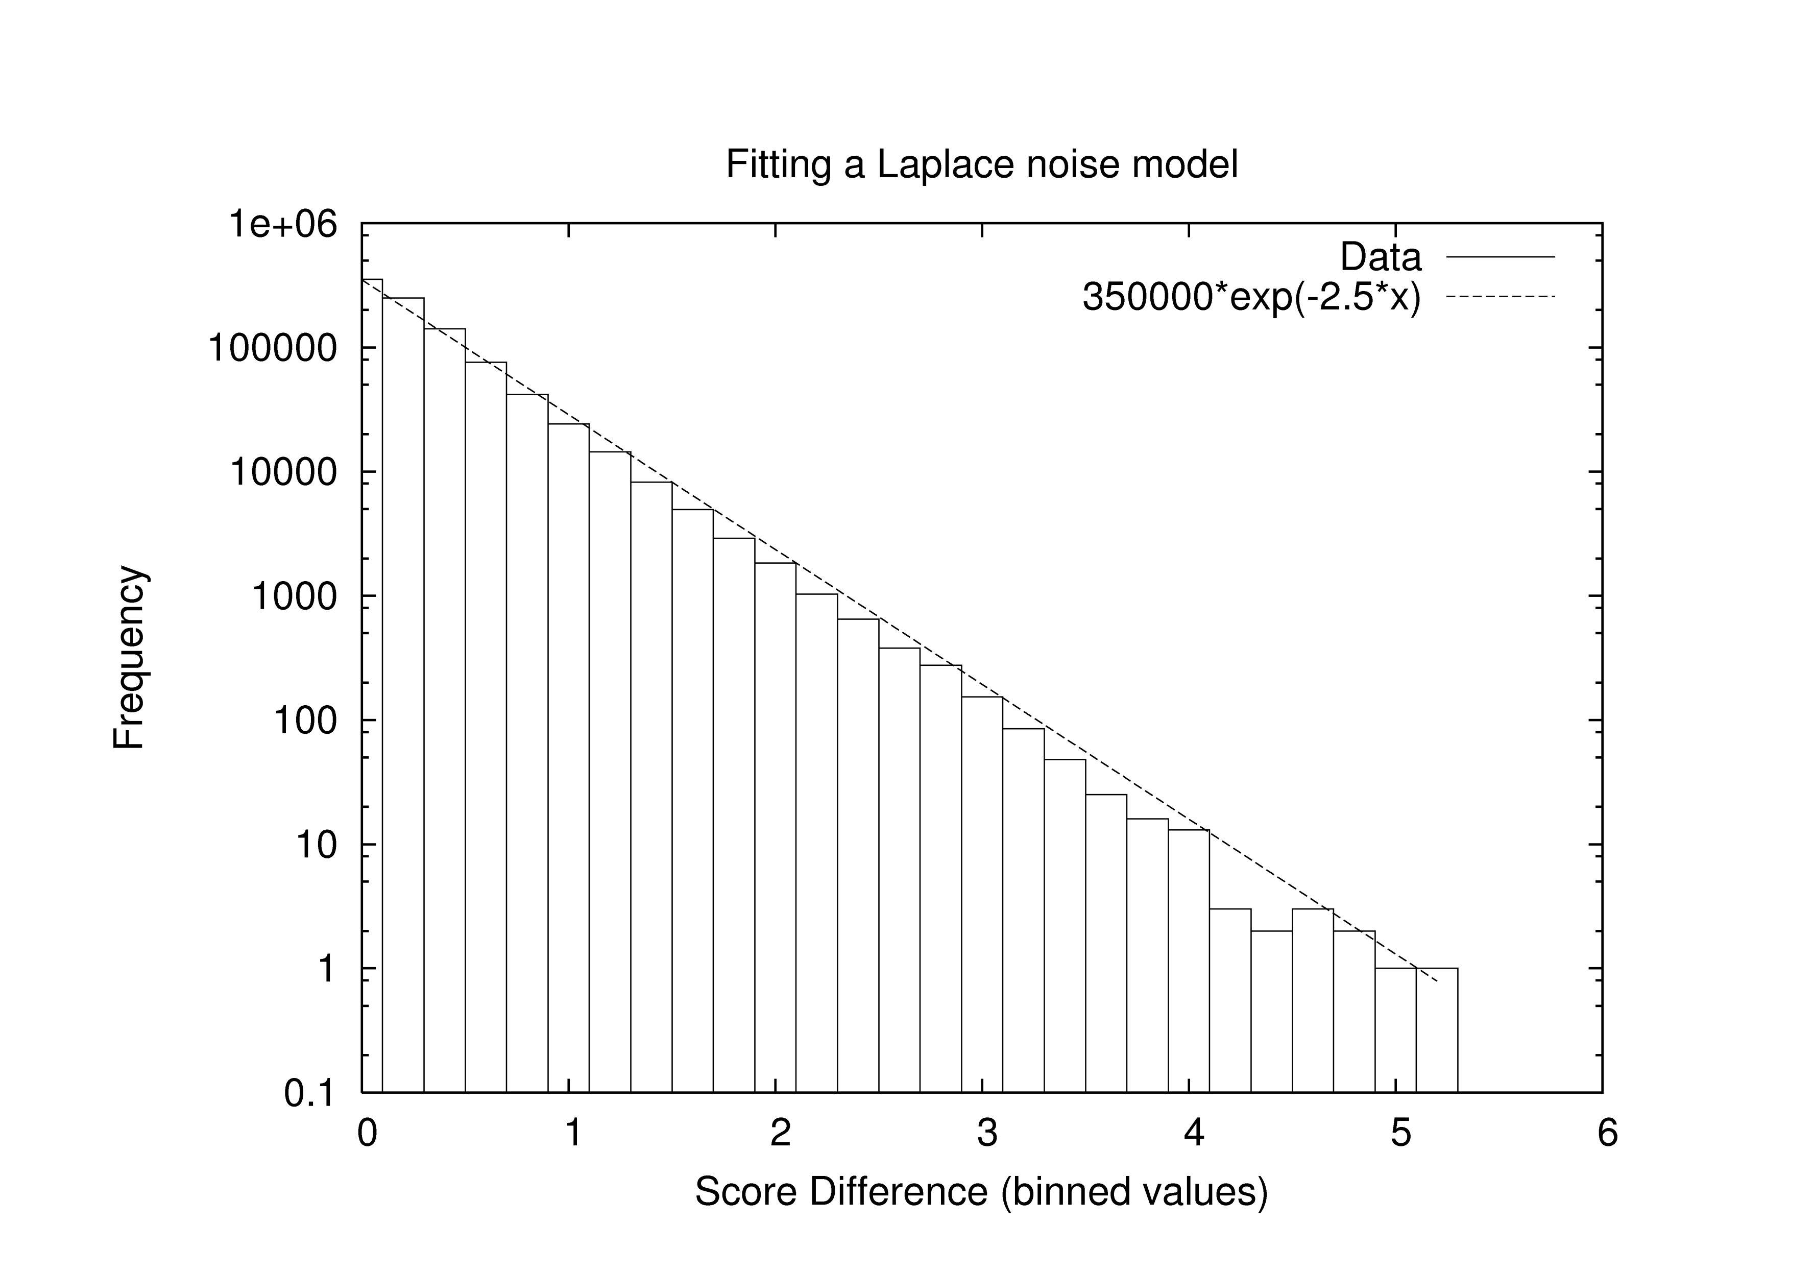
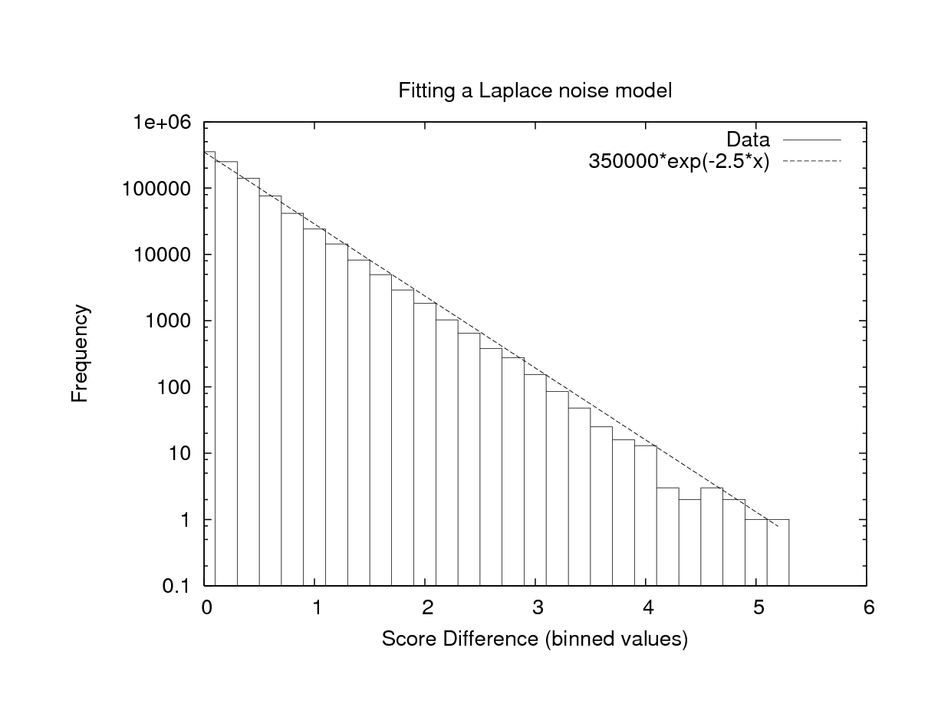

Supplementary figure 1. Histogram of score difference against final normalized score.

K | # local optima |  | min | Q1 | median | mean | Q3 | max
0 | 10913.4 | basin size | 1.22 | 18.74 | 35.02 | 103.00 | 74.5 | 23507.8
 |  | max. diam | 10 | 10 | 10 | 10.00 | 10 | 10
 |  | max diam (10%) | 8.88 | 9.86 | 9.96 | 9.90 | 10 | 10
 |  | max diam (1%) | 7.46 | 8.32 | 8.8 | 8.78 | 9.08 | 9.9
 |  | walk length | 0 | 2.04 | 3.22 | 3.59 | 4.98 | 14.64
1 | 8661.72 | basin size | 1 | 19.16 | 38.5 | 124.65 | 92.8 | 13816.48
 |  | max. diam | 10 | 10 | 10 | 10.00 | 10 | 10
 |  | max diam (10%) | 9.68 | 10 | 10 | 10.00 | 10 | 10
 |  | max diam (1%) | 8.56 | 9.48 | 9.84 | 9.69 | 9.96 | 10
 |  | walk length | 0 | 2.02 | 3.06 | 3.36 | 4.3 | 13.48
2 | 7520.44 | basin size | 1.04 | 20.26 | 43.64 | 140.87 | 114.16 | 9737.8
 |  | max. diam | 10 | 10 | 10 | 10.00 | 10 | 10
 |  | max diam (10%) | 9.98 | 10 | 10 | 10.00 | 10 | 10
 |  | max diam (1%) | 8.98 | 9.9 | 10 | 9.89 | 10 | 10
 |  | walk length | 0 | 2 | 3 | 3.18 | 4 | 12.7
3 | 7682.88 | basin size | 1 | 21.56 | 48.68 | 136.71 | 128.64 | 5565.6
 |  | max. diam | 10 | 10 | 10 | 10.00 | 10 | 10
 |  | max diam (10%) | 10 | 10 | 10 | 10.00 | 10 | 10
 |  | max diam (1%) | 9.14 | 10 | 10 | 9.96 | 10 | 10
 |  | walk length | 0 | 2 | 3 | 2.94 | 4 | 11.72
Supplementary Table 1. Properties of quaternary NK-models with increasing values of K (N=10) in terms of local optima, based on 100 instances. Q1 = lower quartile, Q3 = upper quartile.

Supplementary figure 2. Sensograms from the fittest sequence (5’ATCTCATCGC3’), as determined by SPR. i) Injection points are marked a-sample injection, b-wash c-surface regeneration. APC was injected onto the aptamer-immobilized SA chip at a range of concentrations varying between 5μM to 100nM (5, 2.7, 1.3, 0.3, and 0 μM shown here) under running buffer at a flow of 25 μl/min. ii) enlarged view of injection and wash stage, black lines represent the best fit determined for kinetic data. The on rate was measured as 1.98 × 10³ M⁻¹S⁻¹, off rate as 3.73 × 10⁻³ S⁻¹, affinity 1.88 × 10⁻⁶ M.

Experimental SPR procedure

Binding constants were measured using Surface Plasmon Resonance, SPR, (Biacore 3000). Two DNA sequences, the best sequence as well as the highest scoring sequence that failed to start with “5’AT….” (5’GGTTGGGCGT3’) were immobilized onto a Biacore SA chip. Solutions of biotinylated aptamers (30 μM) were flowed over individual channels at a flow rate of 20 μl/min, for 2 mins. APC present in PBS at various concentrations (5μM – 100 nM) was passed over the Biacore chip (25 μL s-1 at 37°C): between samples the chip was reconstituted with 50 mM NaOH. A blank reference cell value was subtracted from all sensograms, and binding calculated via the BIA evaluation software v4.1 using the Langmuir model.
Supplementary figure 2 shows the curves for the best sequence; the second sequence tested (5’GGTTGGGCGT3’) failed to produce curves for analysis. We cannot rule out the interaction of the sequence and the protein, but any interaction appeared to be below the sensitivity of the experiment.

